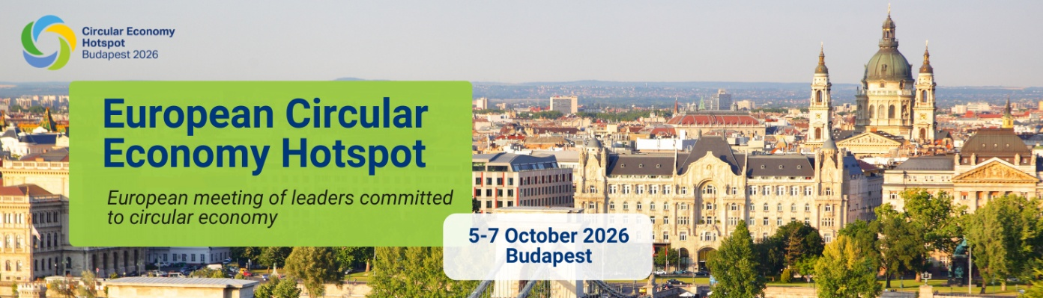
Dear XY,
The transition to a circular economy is already underway—the question is, who will be there when the next steps are taken?
We are pleased to announce that early bird registration for the European Circular Economy Hotspot Budapest 2026 is now open. – Secure your spot at one of the most exciting international events on the circular economy at a discounted rate via the link below.
REGISTRATION
The Circular Economy Hotspot is Europe’s leading gathering of decision-makers and innovators working to accelerate the transition to a circular economy — and for the first time, it is coming to Hungary. This is not a traditional conference, but a platform for concrete business solutions, policies, financing opportunities, and collaboration that drive circularity forward.
Among our confirmed speakers are internationally renowned experts including Tom Szaky, Founder and CEO of TerraCycle, Prof. Dr. Diana Ürge-Vorsatz Vice-President of IPCC, Peter Börkey Circular Economy Lead of OECD, and Janez Potočnik Co-chair of the UNEP IR Panel.
The detailed programme is available here.
Should you have any questions, please contact us at cehotspotbudapest@bcsdh.hu
The official language will be English, with Hungarian interpretation available.
Best regards,
Irén Márta
on behalf of the organisers of Circular Economy Hotspot Budapest
Managing Director of BCSDH

Thanks to our sponsors:
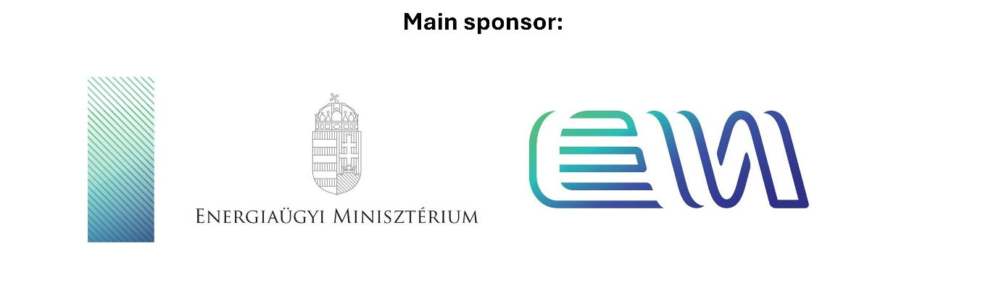

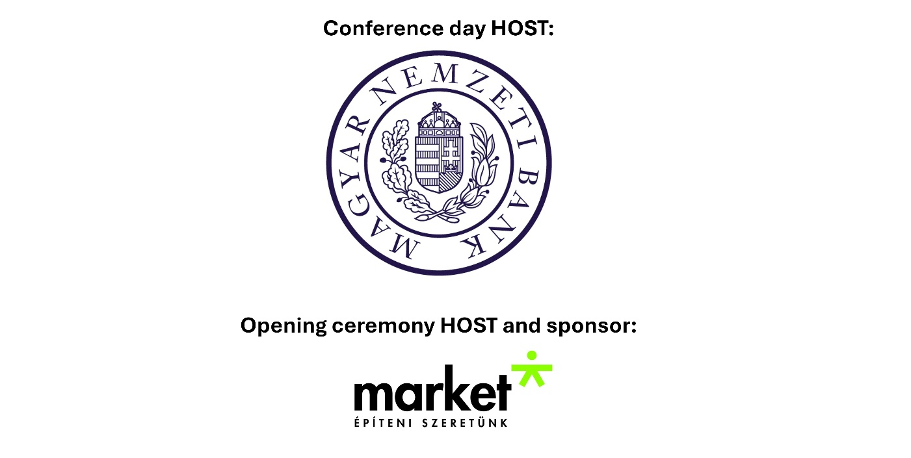
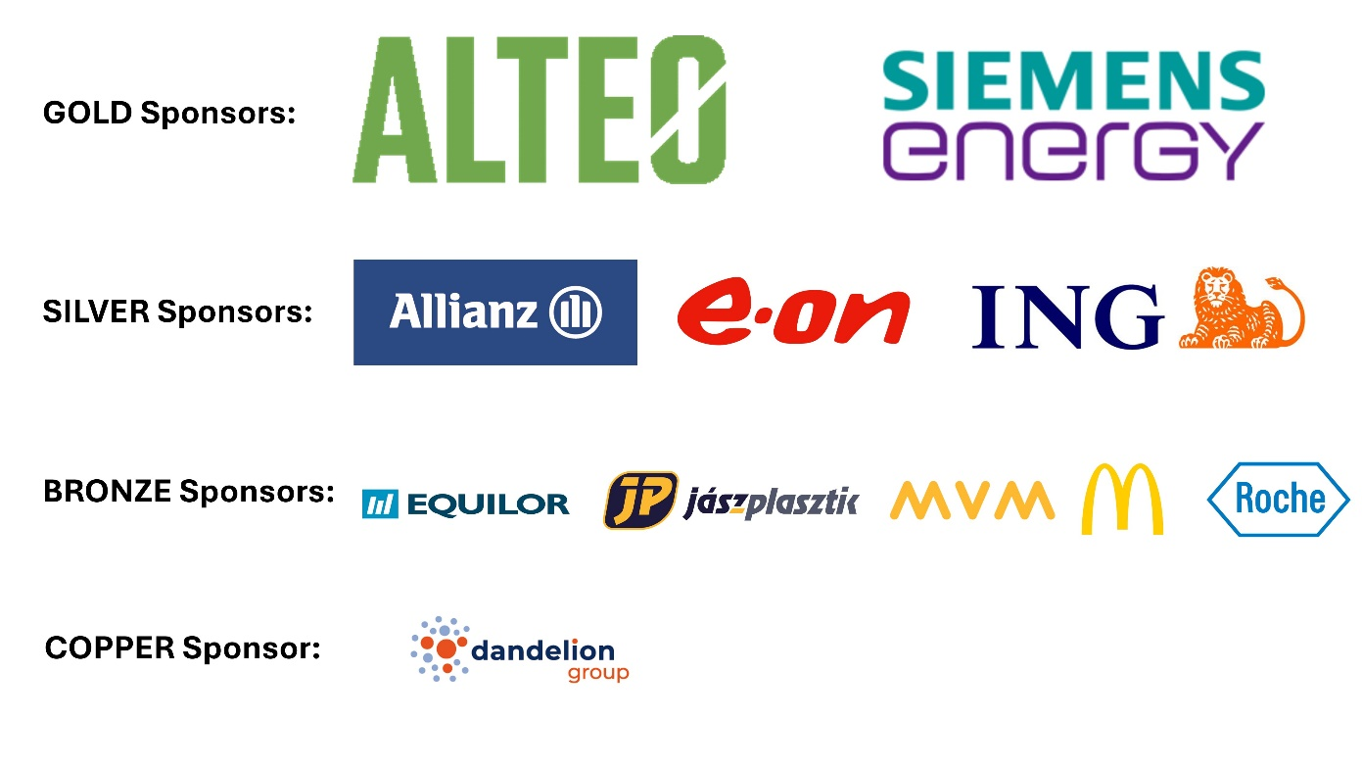

Recommended event - ENVIRONTEC powered by ÖKOINDUSTRIA exhibition: 7-9 October.
From 7–9 October 2026, the international ENVIRONTEC powered by ÖKOINDUSTRIA trade exhibition will once again take place at HUNGEXPO. The event is a key meeting point for sustainable economic transition, green technologies, and circular solutions — bringing together professionals, decision-makers, and innovators from across sectors. For further information, click here.

